Subjective Questions

- Explain the revenue breakdown by year and by-product. Evaluate how different products contribute to annual revenue and come up with suggestions to increase the sales of the low-selling items.

  - Reference for revenue breakdown by year:

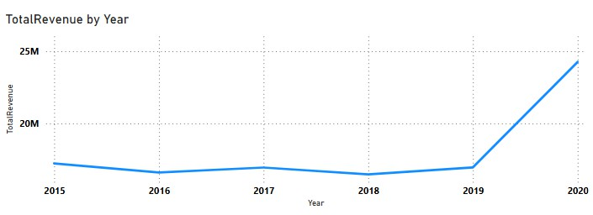
Reference for revenue breakdown by product:

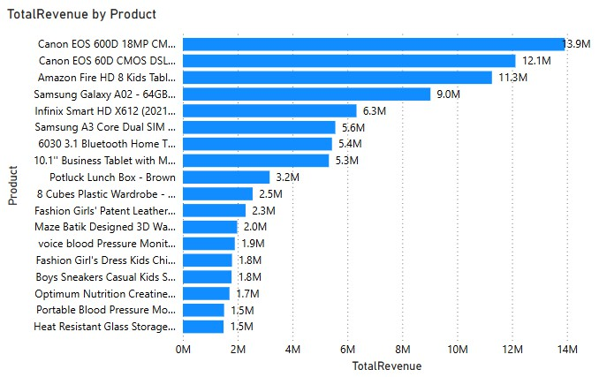
Strategies to Increase Sales of Low-Selling Items:
    - Combine low-selling products with top-performing items as part of a bundle deal.
    - Provide special discounts on low-selling items for a limited time to boost demand.
    - Place low-selling products in the "Recommended for You" or "Trending Now" section.
    - Compare pricing with competitors and adjust accordingly.
    - Encourage customers to leave positive reviews for underperforming items.
    - Retarget interested customers who viewed but didn’t purchase low-selling products.
    - If a product has low sales in certain locations, check if it's due to stock unavailability. Use zone-wise analysis to optimize inventory distribution.

How many products were returned? Use a DAX function to get this metric. Examine the possible reasons for returns and consider how this metric could indicate improvements in product descriptions or quality control.

Create a Measure for Returned Products


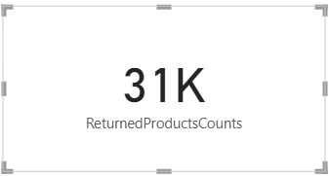
Analyse Reasons for Returns
    - The Reason column provides insights into why products were returned.
    - Create a Count of Each Return Reason by following formula:
ReturnProductsCount = COUNT(Orders[Reason])
    - Insert a Table Visual.
    - Drag Reason and ReturnProductsCount into the table.
    - Sort the table in descending order to see the most common return reasons.

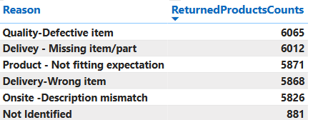

Insights from the data to Examine the possible reasons for returns and consider how this metric could indicate improvements in product descriptions or quality control:
- Quality - Defective Item
Issue:
  - “Quality-Defective Item” (6,065) is the most common reason for returns.
  - Faulty manufacturing or improper handling may be leading to damaged goods.

Solution:
  - Implement stricter quality checks before shipping.
  - Use AI-driven quality control in warehouses to detect product defects.

Delivery - Missing Item/Part
Issue:
  - Items with missing parts indicate incomplete packaging or supply chain issues.

Solution:
  - Add checklists at packaging stations to confirm completeness.
  - Implement barcode scanning to verify that all required parts are included.
  - Add checklists at packaging stations to confirm completeness.

Product - Not Fitting Expectation
Issue:
  - Customers return items because they don’t match their expectations, possibly due to misleading descriptions or images.

Solution:
  - Improve product descriptions by including detailed specifications.
  - Use high-quality images & 360-degree product views.
  - Add customer reviews and Q&A sections to clarify doubts.
  - Provide a "Size Guide" or "Comparison Tool" for apparel and electronics.

Onsite - Description Mismatch
Issue:
  - Customers are getting items that do not match what was shown online.

Solution:
  - Cross-check product listings with actual items before listing.
  - Require vendors to submit real customer photos instead of only stock images.

Delivery - Wrong Item
Issue:
  - Incorrect products are being sent, possibly due to warehouse mislabelling or human error.

Solution:
  - Improve order verification systems before shipment.
  - Introduce a "Live Order Check" where customers can confirm their order before shipment.

Whenever a customer goes to Amazon, they’ll filter the most rated products to buy the better category. Can you verify this using any visualization or table that the ratings of products impact their sales value?


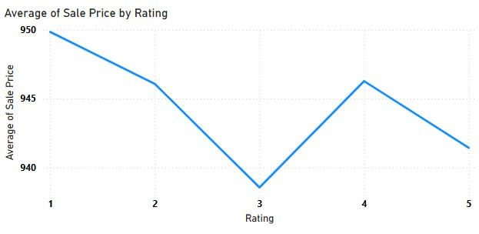

Insights and Targeted Marketing Strategies:
- Customers are likely to filter for highly rated products, as indicated by the significant sales increase for products rated above 4. This suggests that ratings significantly influence purchasing decisions.
- Focusing marketing efforts on products with higher ratings can enhance sales.
- Products with lower ratings should be analyzed for potential improvements like customer reviews can provide insights into issues that need addressing, which can boost ratings as well as sales.

Investigate how revenue distribution varies across different locations. Explore which geographical areas contribute most to sales and consider the strategic implications for regional marketing and distribution efforts. How might location-based trends inform the company's market segmentation and resource allocation approach?


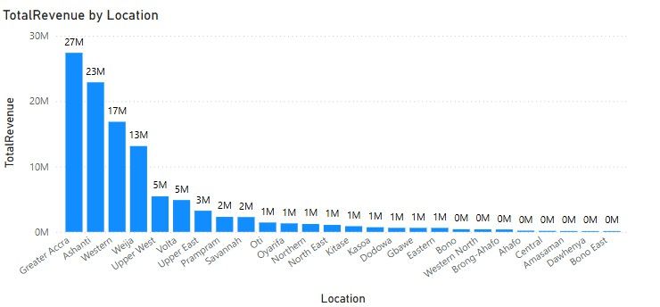


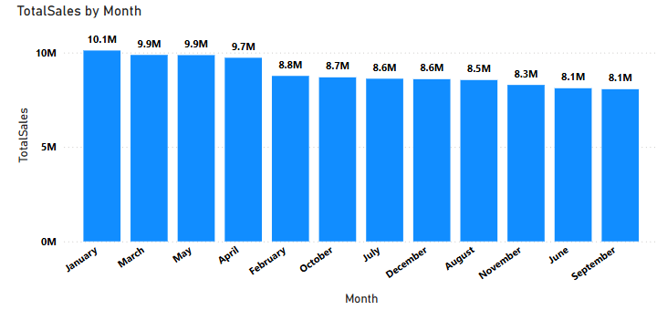
Insights and Targeted Marketing Strategies:
- Greater Accra stands out as the highest revenue-generating region with 27M. This suggests that it is a critical market for business.
- Other contributors like Upper West and Eastern regions also generate significant revenue, indicating multiple strong markets.
- Areas from Oti show relatively low revenues as shown above. This highlights potential areas for improvement or targeted marketing efforts.
- Location-based trends can significantly inform a company's market segmentation and resource allocation strategy in several ways:
- By analysing revenue data by location, the company can identify which regions contribute the most to overall sales.
- Variations in purchasing behaviour across locations can lead to the development of localized versions of products or services to better meet customer expectations.
- Understanding geographical revenue distribution can help in planning logistics and distribution strategies, ensuring that high-demand areas are well-stocked while optimizing inventory levels in less productive regions.

Determine which month could benefit from enhanced promotional offers to boost sales. Can you suggest some targeted marketing strategies here?

Insights:
- January (10.1M) has the highest sales and doesn't require boosting.
- June(8.1M), September(8.1M) and November(8.3M) represent sales dip below the average(9M) and should be targeted for enhanced promotions.
- July, August, October, and December show consistent but lower-than-ideal sales that can benefit from specific seasonal promotions.

Targeted Marketing Strategies:
- Discount & Cashback Offers:
  - Offer higher discounts on slow months.
  - Implement limited-time cashback offers to encourage spending.

Prime Membership Incentives:
  - Provide extra perks for Prime members, such as free express delivery in low-sales months.
  - Offer exclusive early access to deals.

Personalized Promotions:
  - Use customer purchase history to send customized discount coupons.
  - Offer bundle deals based on customer preferences.

Festive & Event-Based Marketing:
  - Align promotions with local festivals or shopping holidays.
  - Like October for Halloween promotions, November and December Focusing on Black Friday, Diwali last-minute gift deals, "12 Days of Christmas" offers, gift bundles

Referral & Loyalty Programs:
  - Encourage existing customers to refer friends with referral discounts.
  - Offer loyalty points redeemable in the next purchase.

Identify which products may require increased marketing efforts. Which items have high prices yet underperform in sales?


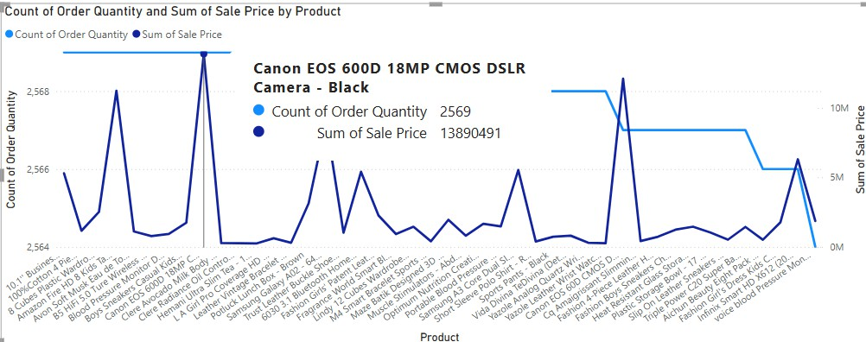

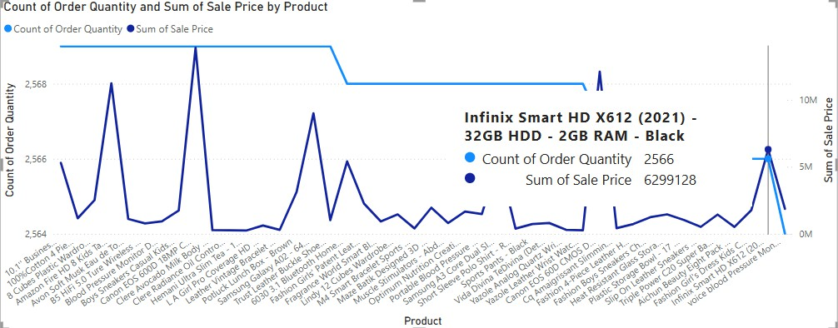

Insights:
- After analysing the product performance data, two items stand out as having high prices, but underperforming sales as shown in above references.
- These two products are priced higher than most competitors in its category but has not shown strong sales figures. It is possible that customers perceive it as overpriced or are unaware of its value proposition.
- This combination suggests that these products may benefit from targeted marketing interventions to drive demand and justify their pricing.

Targeted Marketing Strategies:
- Offer limited-time price drops or bundled discounts with related items.
- Use data-driven targeted ads on Amazon, social media, and email campaigns.
- Partner with influencers to showcase product value.
- Revisit the pricing strategy. If this product is priced similarly to competitors but lacks distinct advantages, adjusting the price slightly or improving its features may help boost sales.

Assess which products should have discounts. How can targeted incentives drive sales and customer loyalty for specific products?

Insights:
- As shown in above figure, we have 2 products i.e.
- Canon EOS 60D DSLR Camera Bundle-18-55mm lens-Black and Infinix Smart HD X612(2021)-32GB-2GB RAM- Black, where sales are high in price and less in order quantity.
- Products with a high price tag but low quantity volume can be seen as too expensive by customers. Offering a targeted discount can help make these products more appealing to buyers who might hesitate to pay full price.

Targeted Marketing Strategies:
- Targeted incentives, like time-limited offers or exclusive deals, create a sense of urgency, motivating customers to buy now.
- Offering discounts to customer preferences or purchase history can encourage hesitant buyers to make a purchase.
- Give welcome discounts to encourage future purchases.

Come up with a loyalty program to benefit the company’s customers. From the available lot of customers come up with strategies to bucket them and provide benefits under different loyalty programs.
  - The goal of this loyalty program is to increase customer retention, boost repeat purchases, and enhance customer satisfaction by offering tailored benefits. To do this, created different loyalty tiers based on purchase behaviour.

To categorize customers, used three key factors:
- Purchase Frequency (How often a customer buys)
- Total sales
- Order quantity
- Customer Rating

Using this, divided customers into four loyalty tiers:

Platinum Tier (High-Value Customers)
Criteria:
  - 8-10 orders per month.
  - High total sales (Top 10% of all customers)
  - Low return rate and high customer ratings. Benefits & Strategies:
  - Free Next-Day or Express Delivery
  - Personalized Product Recommendations
  - Extra Cashback (5%–10%)
  - Exclusive Early Access to Sales

Gold Tier (Frequent Buyers)
Criteria:
  - 5-7 orders per month
  - Moderate to high total spend
  - Occasional returns, decent customer ratings


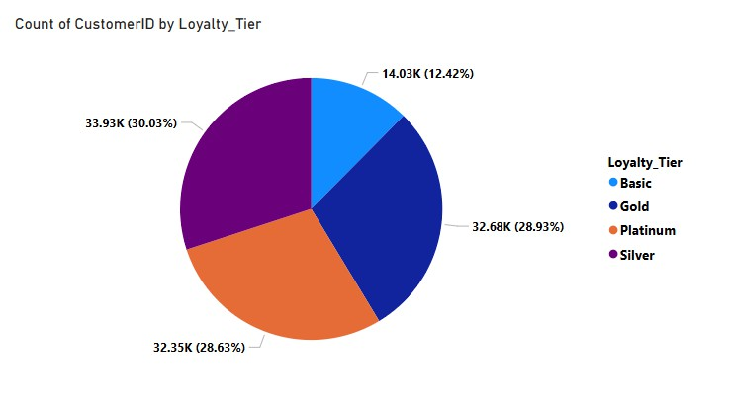
Benefits & Strategies:
  - Loyalty Coupons (like some amount off on purchases above)
  - Bonus Points on Special Events (festivals, birthdays, etc.)
  - Refer & Earn Program (₹200 credit for bringing new customers)

Silver Tier (Occasional Shoppers)
Criteria:
  - 2–5 orders per month
  - Medium spending pattern

Benefits & Strategies:
  - Limited-Time Discount Offers
  - Free Shipping on Orders Above some amount.
  - Offer 1-month free trial of Prime-membership to convert them into loyal customers.

Basic Tier (Inactive Buyers)
Criteria:
  - Only 1 purchase in the last 3–6 months
  - Low engagement, minimal spending

Benefits & Strategies:
  - Welcome Back Discount (Some amount Off on Next Order)
  - Email / SMS Campaigns with Personalized Deals

Report:

- Customer Segmentation


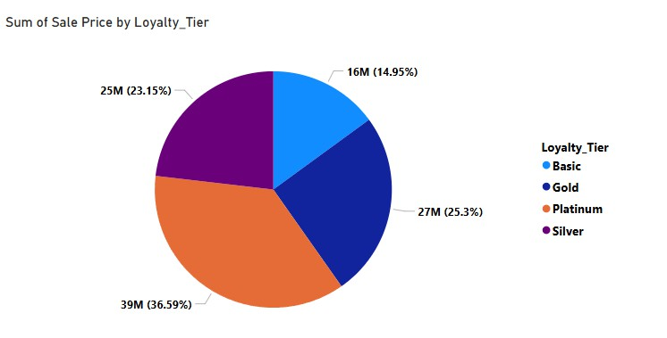
- Revenue by Loyalty Tier

Using the DAX functions Calculate and a row iteration DAX function calculate the total sales for the Product Category “Fashion” and delivery type “Shipped from Abroad”. What are the other types of DAX functions you have used in the project?


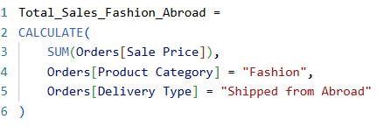

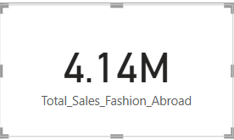
Other DAX Functions Used in the Project are:
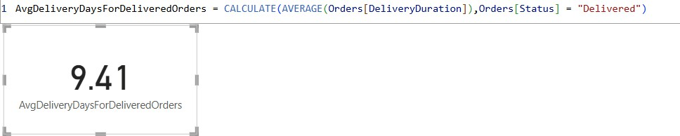
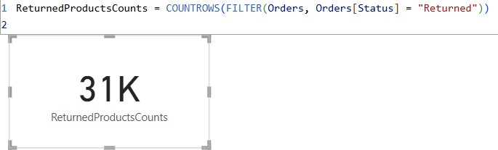

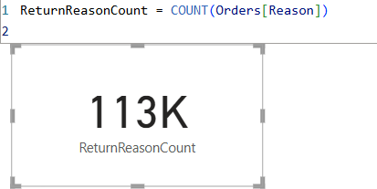
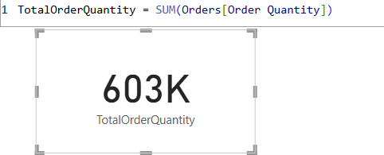

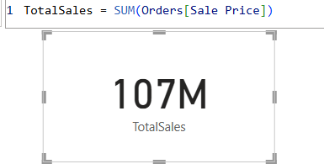
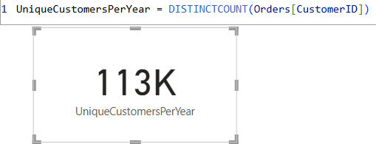
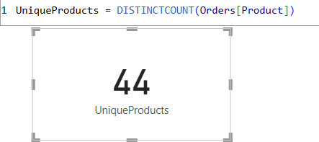
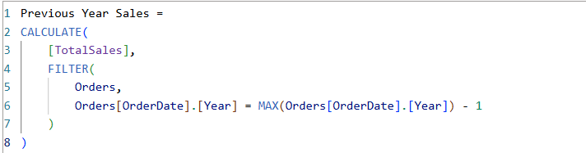

Wait Times Correlated with Demographics and Care: Explore how average wait times vary across different product categories to optimize scheduling and staffing.
  - I have already calculated Delivery Duration which is the duration between order date and delivery date, and it is same for wait times as well.
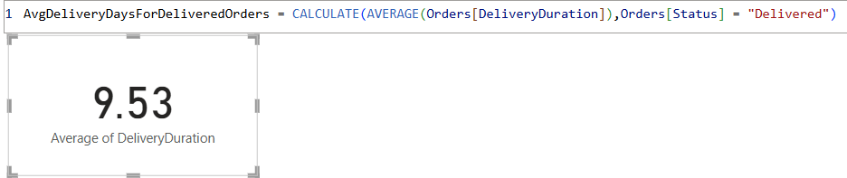

Visualization:

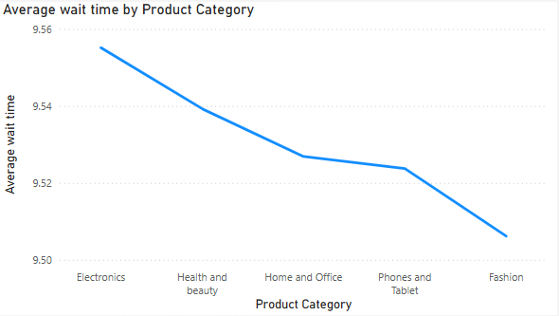
- Axis: Product Category Y-Axis: Average Wait Time

Insight:
  - Electronics has the longest average wait time (9.554 days), suggesting that there may be inefficiencies or delays in processing orders in this category.
  - Health and Beauty, although slightly higher than Home and Office, still falls into a higher category of wait times compared to others, indicating a potential issue in fulfilment processes for this category.
  - Fashion, Phone and Tablets, and Home and Office have relatively closer wait times, though Fashion still has a lower average compared to the others, indicating a more efficient processing system for this category.

Strategies to optimize scheduling and staffing:
  - Allocating more staff or optimize fulfilment processes to reduce delays in this Electronics category.
  - Ensuring the current staff levels are maintained but be prepared to scale during peak demand periods.
  - By leveraging data to forecast high-demand periods (e.g., holidays) and adjust staffing levels to ensure timely order fulfilment across all categories.

Explore if there is any relationship between the Delivery type and waiting time between ordering and receiving an item.

Visualization:
X axis – Delivery Type
Y axis – Average wait time

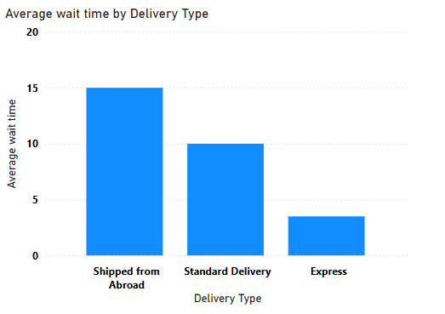

Insights:
- Shipping from Abroad has the highest average wait time (15.0 days), indicating that international shipping or logistics may be causing significant delays. This could be due longer transit times, or limited shipping options.
- Standard Delivery has a moderate wait time of 10.0 days, suggesting that domestic deliveries take a reasonable amount of time but may still have room for improvement.
- Express Delivery has the shortest wait time (3.5 days), which is ideal for customers who value quick delivery. However, since it’s significantly faster, it might suggest that customers are willing to pay a premium for faster service.

Recommendations:
- Partner with faster international carriers to reduce the long wait times for Shipped from Abroad.
- Improve customs clearance processes to minimize delays in international shipments.
- Prioritize Express Delivery during peak times to maintain the quick 5-day delivery window.
- Use better tracking systems to keep customers informed about their orders and manage expectations.
- Adjust staffing levels based on demand for different delivery types, particularly during peak seasons, to avoid delays


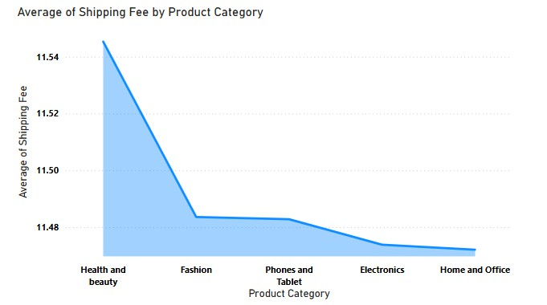
Is there any relationship between shipping charges and product type?

Visualization
X axis - Product Category
Y axis - Avg of shipping fee

Insights and Recommendations:
- The shipping charges for all the product types are almost identical, ranging from
11.47 to 11.55. This indicates that the shipping charges do not vary significantly across these categories in our data.
- This could imply that the company uses a standardized shipping fee regardless of the product type, which is common in e-commerce businesses where flat- rate shipping fees are applied for convenience.
- The minimal difference suggests that the shipping fees are either fixed or determined by factors other than the product type, such as the size, weight, or delivery location, rather than the product's category.

Come up with strategies to decrease the low rating orders after analysing different factors like waiting time, shipping type, unit price, etc.

Visualization
X axis – Delivery Type
Y axis - Average Waiting Time’ and ‘Average Unit Price
Tooltip – Average Rating

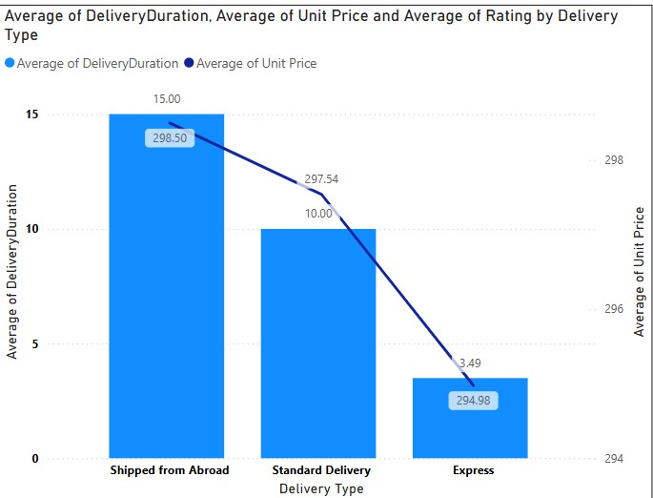

Insights:
- Longer wait times are associated with lower ratings, particularly for Shipped from Abroad deliveries.
- Express Delivery maintains relatively high ratings and having lower wait times, indicating that customers value speed.
- Standard Delivery with average wait times, leads to better ratings and suggesting customers appreciate faster delivery.

Recommendations:
- Reducing Waiting Time:
  - Optimize Inventory Placement: Use demand forecasting to place products in fulfilment center closer to high-order regions.
  - Faster Order Processing: Automate picking and packing processes to reduce delays.
  - Improved Order Tracking: Provide real-time tracking updates and estimated delivery time adjustments.
  - Same-Day & One-Day Delivery: Expand these options for frequently purchased products.

Improving Shipping Type:
  - Partner with More Logistics Providers: Increase efficiency by collaborating with local delivery partners.
  - Reduce Last-Mile Delays: Use AI-powered route optimization and local delivery hubs.

Adjusting Unit Price Strategy:
  - Dynamic Pricing: Use AI-driven pricing strategies to balance affordability with profitability.
  - Bundle Offers & Discounts: Provide better value for money through bundled products or discounts on bulk purchases.
  - Competitor Price Matching: Ensure prices remain competitive to increase perceived value.

Enhancing Product & Service Quality:
  - Vendor Quality Control: Implement strict quality checks for third-party sellers.
  - Customer Reviews Monitoring: Identify common complaints and address recurring issues.
  - AI-Based Recommendation System: Show higher-rated products first to increase sales of quality items.

Customer Experience Improvements:
  - Easy Return & Replacement Policy: A smooth return process builds trust and prevents negative reviews.
  - Proactive Customer Support: AI chatbots and 24/7 support can resolve order issues before they result in low ratings.
  - Loyalty Programs: Offer discounts or credits for customers who provide detailed feedback.

Using the time intelligence DAX function, create a table to compare each month’s sales with the previous year’s same month’s total sales. So there will be four columns in the output year, month, total sales, previous_years_sales.

Calculated Measures for previous year sales:

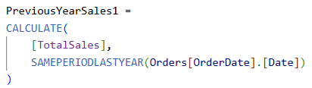
Visualization:
Column: Order date, Total Sales, Previous Year Sales1

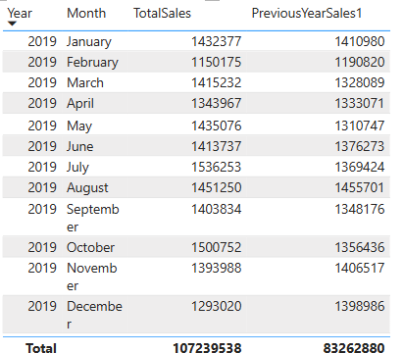

What do you understand by PowerBI gateway? What are its use cases?

  - Power BI Gateway is a bridge between on-premises data sources and Power BI in the cloud. It allows to schedule refreshes, connect to local databases, and ensure that Power BI reports are up-to-date.

Use Cases of Power BI Gateway:
- On-Premises Data Integration: For businesses with on-premises databases, the gateway enables seamless data transfer.
- Real-Time Data: Power BI Gateway allows you to provide real-time analytics.
- Security: Ensures secure data transfer between on-premises and cloud services.
- Hybrid Data Scenarios: Organizations can manage data both in the cloud and on-premises. The gateway supports hybrid setups, making it easier to analyse data across different environments.
- Integration with Other Services: It can be used with other Microsoft services like Azure Analysis Services and SQL Server Analysis Services, allowing for a seamless integration of analytics solutions.

How would you approach this problem, if the objective and subjective questions weren't given?
  - If objective and subjective questions weren't provided in the given problem statement,
here’s how I would approach the task:

Step 1) Data Exploration and Cleaning:
I will start by exploring the dataset. Check the summary statistics to understand key trends. Look for missing values and handle them appropriately. Clean the data by standardizing categories and correcting any inconsistencies.

Step 2) Business Objective:
Focusing on the objectives like boosting sales, optimizing delivery times, improving customer satisfaction, or enhancing product offerings and then identify the areas where business can improve its performance.

Step 3) Key Metrics:
Now by focusing on some key metrics like total sales, customer satisfaction (ratings), product performance, and delivery efficiency that will help overall business and identify areas for improvement.

Step 4) Dashboard:
Finally, creating visualizations that allow stakeholders to interact with the data. By designing the dashboards that provide insights into sales by product, region, and time. This will help the team drill down into the data and make informed decisions.

